Square Root Decomposition

🔷 SQRT DECOMPOSITION (CORE IDEA)
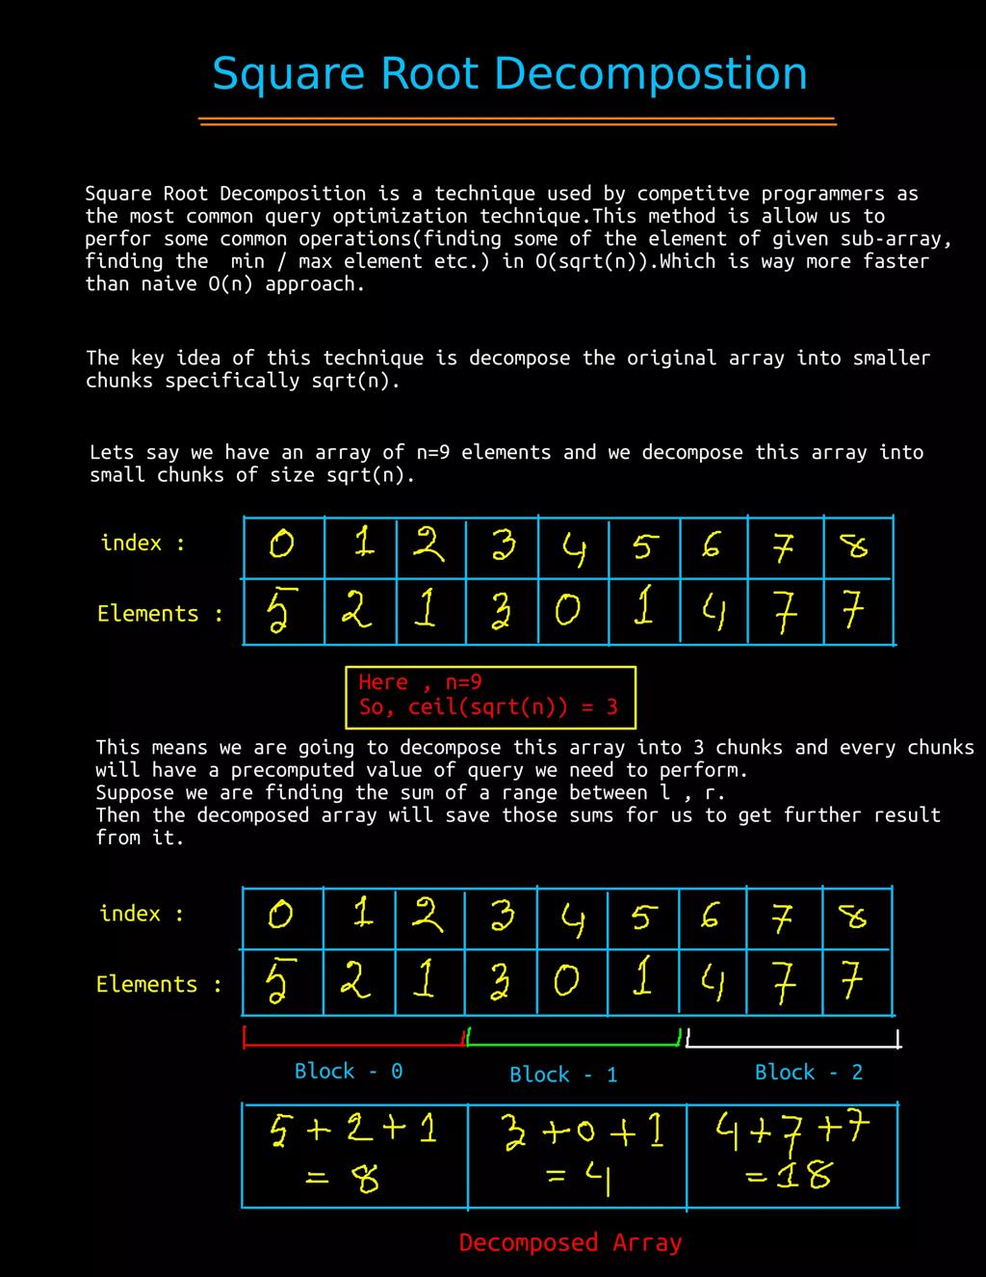
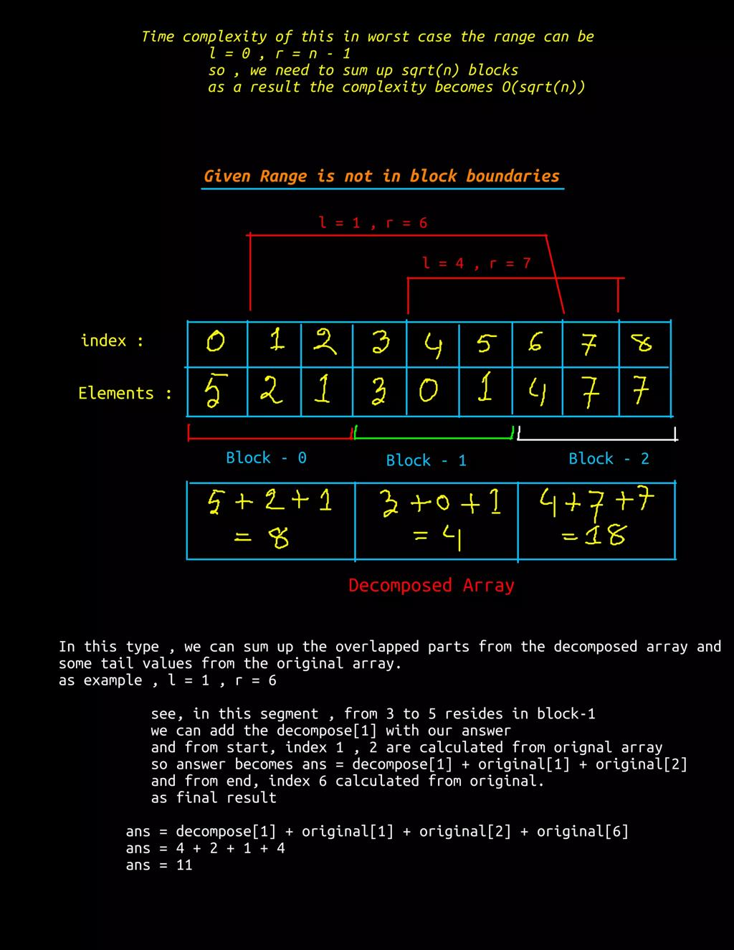
✅ Definition
Square Root Decomposition divides an array into √N blocks to answer queries faster.

📘 Core Intuition
👉 Instead of iterating element-by-element
👉 Jump block-by-block
- Block size = √N
- Number of blocks ≈ √N

🔷 WORKING (STEP-BY-STEP)

🔹 Step 1: Divide Array
Example:
Array = [1, 5, 2, 4, 6, 1, 3, 5, 7]
👉 √9 = 3 → block size = 3
Blocks:
- Block 1 → [1, 5, 2] → sum = 8
- Block 2 → [4, 6, 1] → sum = 11
- Block 3 → [3, 5, 7] → sum = 15

🔹 Step 2: Preprocessing
📌 Steps
- Compute block size = √N
- Create block array
- Store sum of each block

🔷 QUERY (l, r)

🔹 Case 1: Full Blocks Covered
👉 Directly add block sums
Example:
Query(3, 8)
👉 Blocks covered:
- Block 2 (11)
- Block 3 (15)
✔ Answer = 11 + 15 = 26

🔹 Case 2: Partial Blocks
👉 Combine:
- Left partial
- Full blocks
- Right partial
Example:
Query(1, 6)
Steps:
- Add elements: 5 + 2
- Add block: 11
- Add elements: 3
✔ Answer = 21

🔹 Algorithm Steps
- Move to block boundary
- Add full block sums
- Add remaining elements

⏱ Time Complexity
- Query → O(√N)

🔷 UPDATE (index, value)

📌 Steps
- Find block = index / block_size
- Update block sum
- Update array

⏱ Time Complexity
- Update → O(1)

🔷 NAIVE vs SQRT
Approach | Query | Update
Naive | O(n) | O(1)
SQRT | O(√n) | O(1)

🔷 USE CASES
- Range sum queries
- Competitive programming
- Frequent queries

🔄 WITH vs WITHOUT
✔ With SQRT
- Faster queries
- Efficient
❌ Without
- Slow (O(n))

🧠 FINAL MEMORY TRICK
👉 Divide → Precompute → Jump blocks

🧾 FINAL 5-LINE EXAM ANSWER
- Divide array into √N blocks
- Precompute block sums
- Answer queries using blocks
- Query → O(√N), Update → O(1)
- Used for range query optimization

